Lab Azure AD Identities - Lab 01 - Manage Azure Active Directory Identities

Task 1: Create and configure Azure AD users

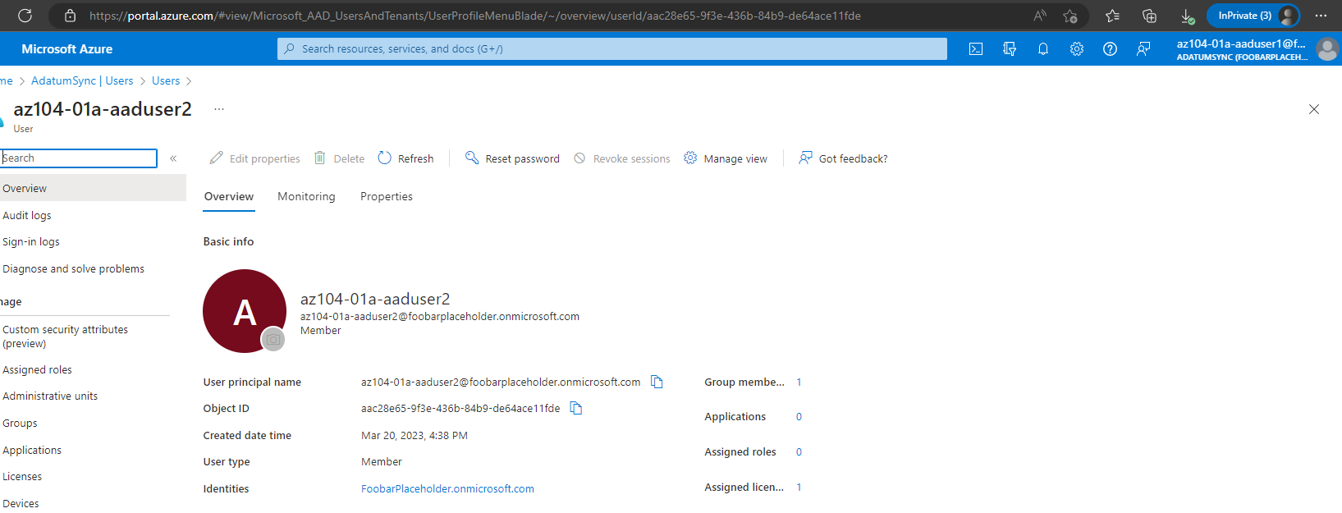

Right after the creation of the second user **az104-01a-aaduser2 via the first created user az104-01a-aaduser1 after assigning the Azure built-in User administrator role to the first user az104-01a-aaduser1.**

**(Please note that screenshots are taken after the Lab is completed, that is why the user is already member of the dynamic group: IT System Administrators)**

**Task 2: Create Azure AD groups with assigned and dynamic membership**

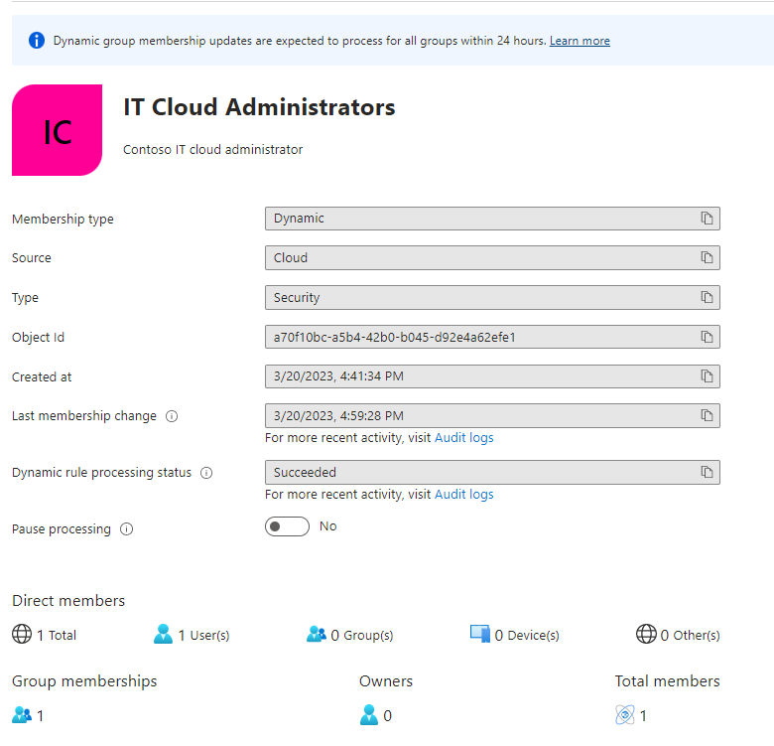

**The group IT Cloud Admnistrators is setup with a dynamic membership with a dynamic rule that if a users jobTitle is equal to System Administrator, the user will automatically be added to this group which could give certain access via assigned group roles to members of the group. (first created user has that title so is a member).**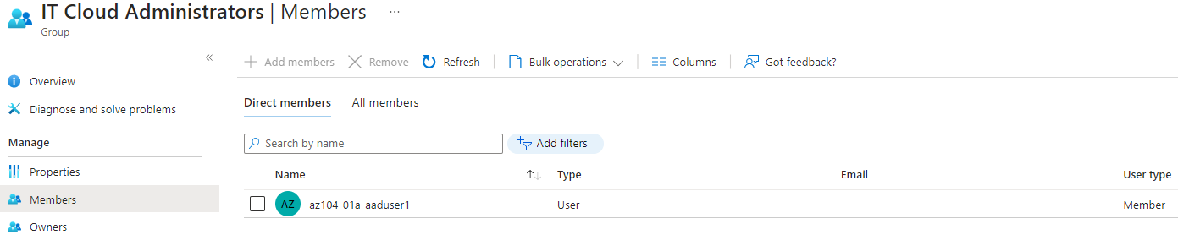

**Task 2: Create Azure AD groups with assigned and dynamic membership**

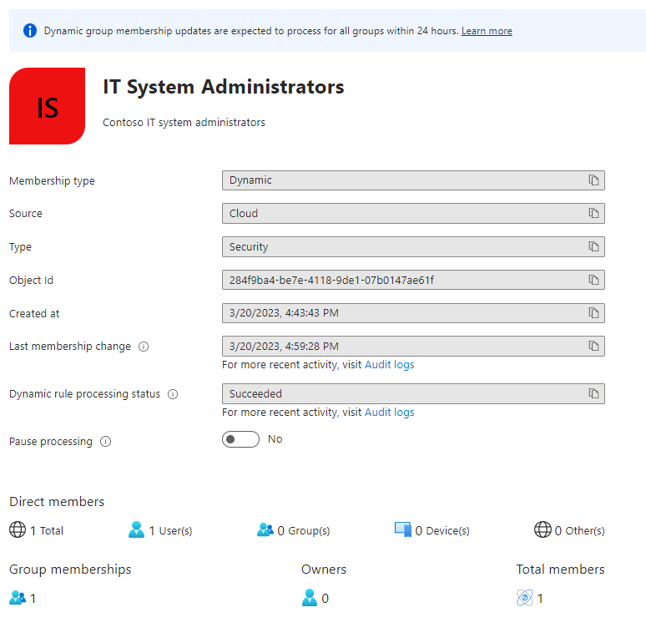

**The group IT System Admnistrators is setup with a dynamic membership with a dynamic rule that if a users jobTitle is equal to System Administrator, the user will automatically be added to this group which could give certain access via assigned group roles to members of the group. ( second created user has that title so is a member).**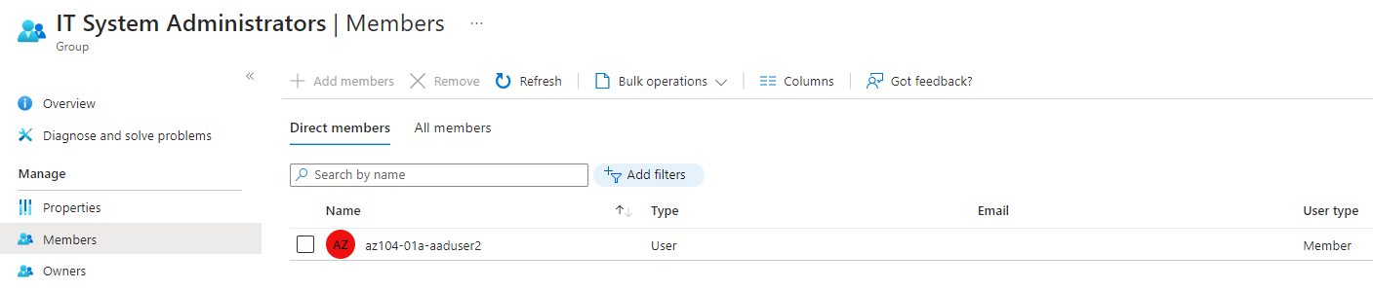

Task 3: Create an Azure Active Directory (AD) tenant

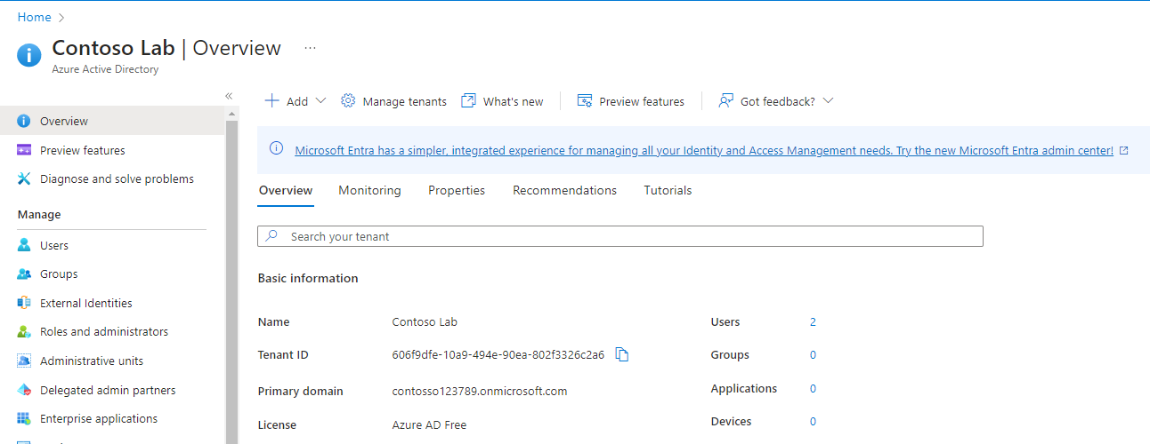

Overview screenshot of the New Azure AD Tenant – please note that screenshot is taken after completing the lab therefore there is more than the 1 default user (my login) present 🡪 **az104-01b-aaduser1**

Task 4: Manage Azure AD guest users

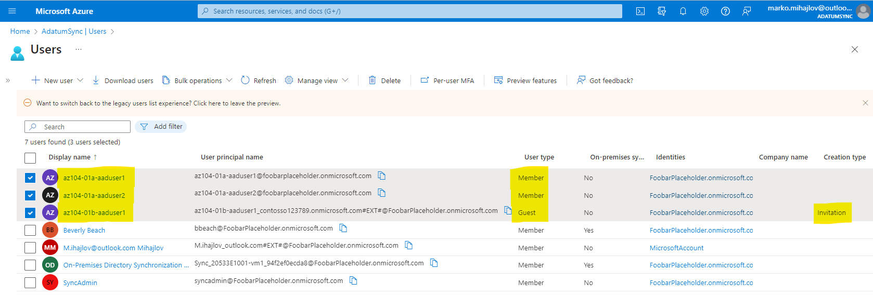

Overview of the Domain ADatumSync with Domain(FoobarPlaceholder.onmicrosoft.com) in which in this Lab the first 2 highlighted users were created internally and the third was invited as a Guest user with cerain default permissions from the other domain that we created Contoso Lab with Domain name (contosso123789.onmicrosoft.com). Similarly to this we were invited with our own accounts into the Scalefocus AD with certain permissions for the purposes of the following SF Academy. ( Teams access, certain File shares access etc. )

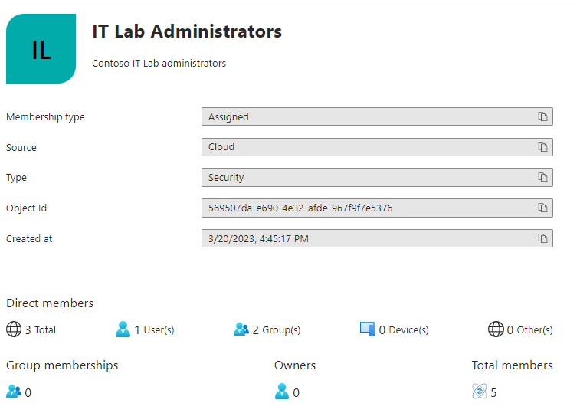

The Group IT Lab Administators is setup to have Assigned membership by directly assigning users or groups to be members. In this case we have assigned the groups IT Cloud Administrators and IT System Administrators which menas that all of their members will automatically be members of this group, additionally we have added the Guest user of the domain as a member of the group which means there are 3 direct members and an additional tab to be selected all members ( which has 5 members, the dynamic groups are listed as members here as well ).

